TECHNICAL PROJECT REPORT

# Title of Invention / Project: Controlling computer using hand gestures

# Team Members / Inventors:

|  |  |  |  |  |  |
| --- | --- | --- | --- | --- | --- |
| **S.No.** | **Name** | **Department** | **Designation** | **Mobile** | **E-Mail** |
| 1. | Ashish | ECE | Student | 9958835299 | anu21jarial@gmail.com |
| 2. | Pritika Diwan | ECE | Student | 9779799165 | [Pritika.diwan271299@gmail.com](mailto:Pritika.diwan271299@gmail.com) |
| 3. | Alekh Anand | ECE | Student | 8503063468 | anandalekh@gmail.com |
| 4. |  |  |  |  |  |
| 5. | Khushal Thakur | ECE | Mentor | 9646030764 | [khushal.thakur@cumail.in](mailto:khushal.thakur@cumail.in) |
| 6. | Anshul Sharma | ECE | Mentor | 9478697475 | [anshulsharma.ece@cumail.in](mailto:anshulsharma.ece@cumail.in) |
| 7. | Kiran Jot Singh | ECE | Mentor | 9463909689 | [kiranjotsingh.ece@cumal.in](mailto:kiranjotsingh.ece@cumal.in) |
| 8. | Divneet Singh Kapoor | ECE | Mentor | 9878422653 | [divneet.ece@cumail.in](mailto:divneet.ece@cumail.in) |

Section – 1 (IPR Related)

# Brief Abstract (500 words):

* **Problem your project is solving**

Reduce hardware cost by eliminating use of mouse.

Convenient for users not comfortable with touchpad.

The framework may be useful for controlling different types of games and other applications dependent on the controlled through user defined gestures.

* **How are you solving that (solution)?**

To solve the above mentioned problems we are trying to make use of hand gestures. To achieve this just connect the two Ultrasonic sensors with Arduino. We know US sensor work with 5V and hence they are powered by the on board Voltage regulator of Arduino. The Arduino can be connected to the PC/Laptop for powering the module and also for Serial communication. Once the connections are done place them on your monitor

# Existing state-of-the-art and Drawbacks in existing state-of-the-art

(*Brief background of the existing knowledge*)

|  |  |  |
| --- | --- | --- |
| **S. No.** | **Existing state of art** | **Drawbacks in existing state of art** |
| 1 | By simply waving our hand we are able to control certain functions on the laptop/computer. | Irrelevant object might overlap with the hand. |
| 2. | By simply waving our hand we are able to control certain functions on the laptop/computer. | System limitations restrict the applications such as the arm must be vertical, the palm is facing the camera. |

# Novel/Additional modifications that you can propose to improve upon drawbacks

*(List down the features)*

* Feature 1: We can simply make use of special type of gloves so that every time we make use of it, it will detect the same pattern .

# Advantages

* Adv 1: This technique is called [Leap motion](https://www.theverge.com/2013/9/19/4745964/hp-envy-17-leap-motion-se-notebook) which enables us to control certain functions on our computer/Laptop by simply waving our hand in front of it.
* Adv 2: The main advantage of using hand gestures is to interact with computer as a non – contact human computer input modality.

# Block Diagram

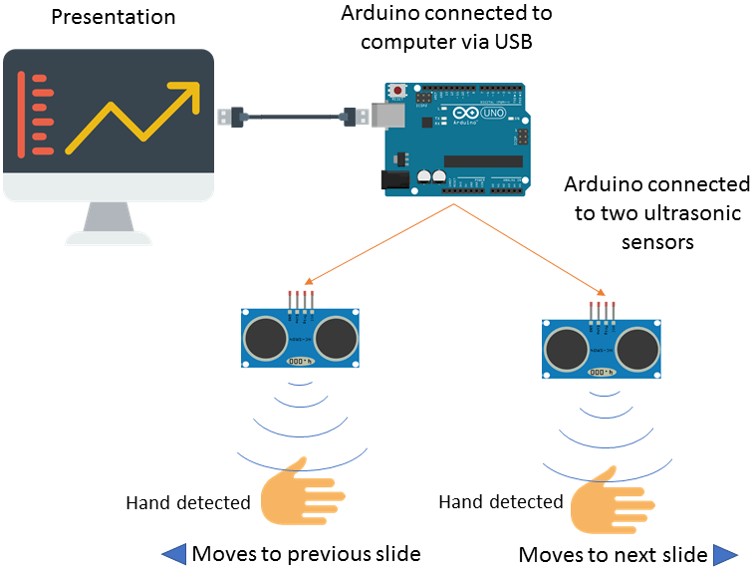

Section – 2 (Real Project)

# Materials

Two ultrasonic sensors , jumping wires, **Laptop/Computer by combining the Power of Arduino and Python**.

# Circuit Diagram

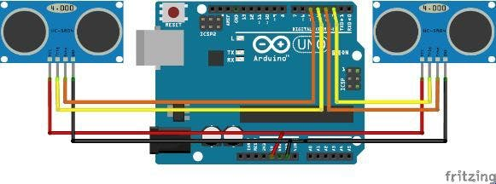

# Steps of Circuit Completion

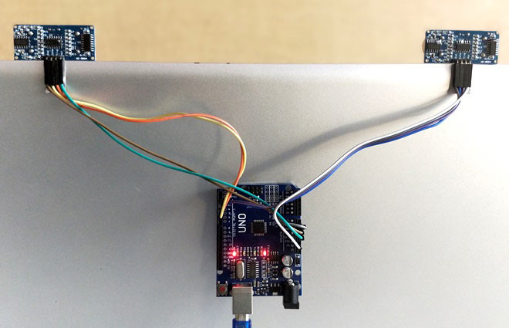

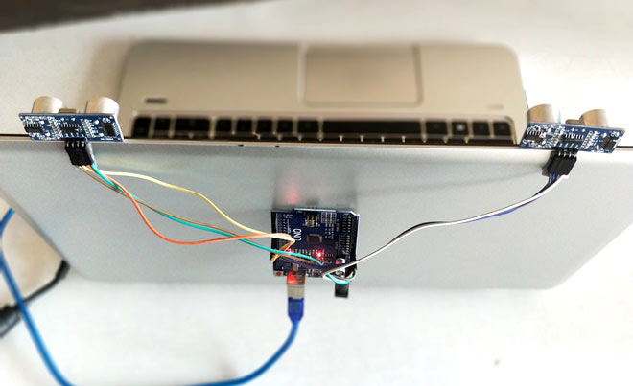

# Program Code

https://github.com/beee-project